COMP 360 AB1

**Group Members:**

Jannine Gemmell, Liam Maarhuis, Ryan Morrison, Kaiya Wangler, Markus Webster

**Kanban Board Pictures:**

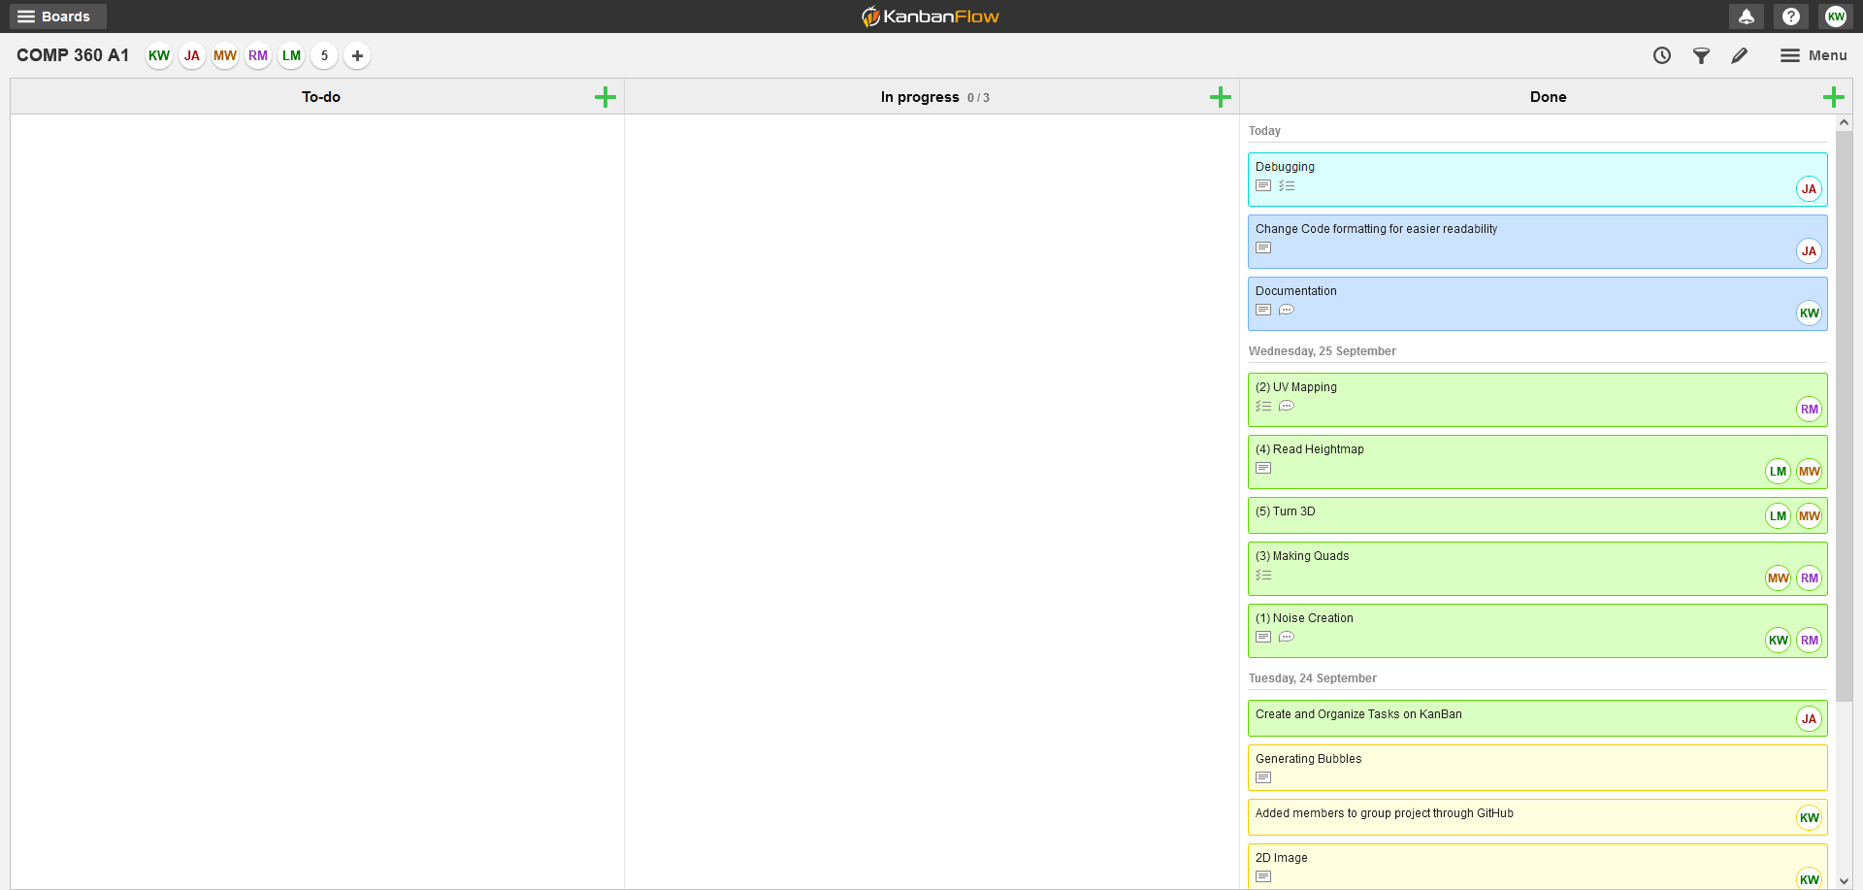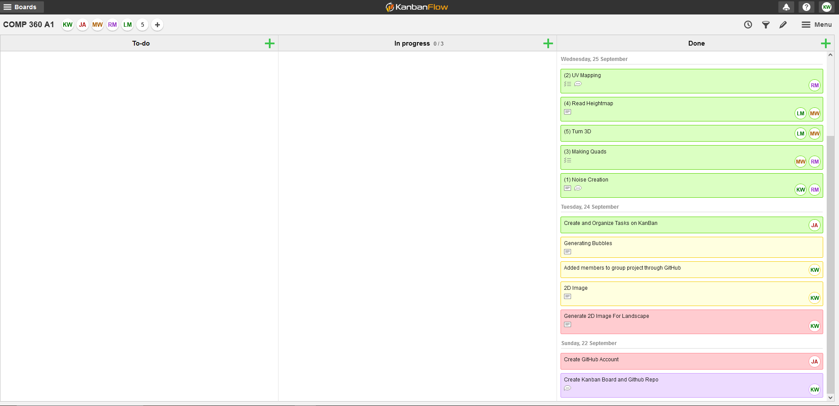

**Github Repo Link:**

<https://github.com/MidnightWolfe/COMP360-A1>